The Twitter Blueprint

Tips And Techniques For Online Marketers

TABLE OF CONTENTS

What Is Twitter?................................................................3
Why Twitter Is An Effective Marketing Tool................................6
How Can You Use Twitter?....................................................6
Getting Started..................................................................11
Signing Up With Twitter..................................................11
Customizing Your Profile.................................................12
Twitter Language / Symbols.............................................13
How To Get Followers...........................................................14
Twitter Etiquette................................................................17
Providing Value on Twitter......................................................19
Writing Eye-Catching, Interesting Tweets....................................21
Twitter Plugins / Widgets.......................................................23
Twitter Tools …....................................................................24
Twitter Services...................................................................25
More Ways To Make Money Using Twitter......................................26
Random Tips & Secrets..........................................................28
Conclusion.........................................................................30

What Is Twitter?

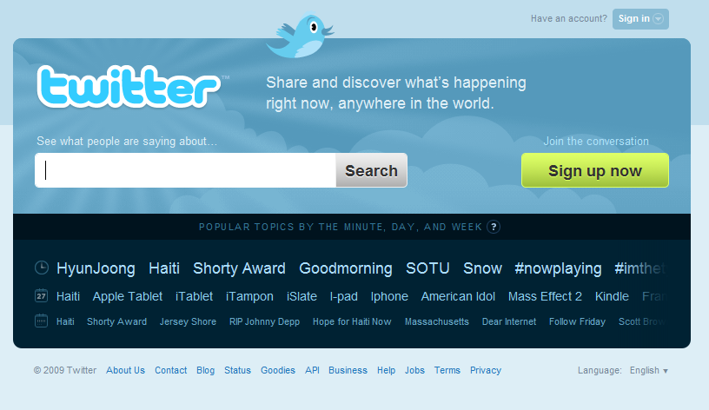

Twitter is a social network and micro-blogging platform that allows you to send 140-character “tweets”. With these tweets, you can let your friends know what you're up to, share links and cool resources, communicate with your customers, drive traffic to your website, and much more.

According to the Twitter website, Twitter allows you to answer the question, “What are you doing?”

Twitter allows you to communicate without the hassle of writing out long blog posts or emails. The format of the Tweet allows you to get away with a link and a few words that can be sent on the go from your cell phone.

And this tweet can potentially reach thousands of customers or business prospects, driving them to your website or blog, and drawing attention to your products.

In turn, you will receive notices whenever someone you are following Tweets something. You can receive instant notification in your browser, cell phone, email, and even on IM clients like AIM or MSN Messenger. Basically, it's more or less impossible NOT to keep touch with your Twitter friends & followers, even if you're out and on the go.

Twitter's extremely simple interface and ease of use is probably one of the reasons why it has caught on like crazy.

Twitter was launched in 2006 by Jack Dorsey, and in 2008/2009 it practically exploded in popularity.

All kinds of celebrities use Twitter on a regular basis to communicate with their fans and followers, from musicians and actresses, to professional athletes and even political figures! Twitter allows us to sneak a peak at what our favorite celebrities are up to. Politicians like Obama use it as a campaign tool

Even large corporations and television networks use Twitter, such as CNN, Amazon, Dell, and ESPN.

Twitter has also been recognized as serving a role in journalism. When US Airways Flight 1549 crashed into the Hudson River, the first photograph was taken by a Twitter user and sent to Twitpic – long before the media arrived.

Twitter users on the ground tweeted about the 2008 Mumbai attacks, compiling lists of the dead and injured and offering important information like emergency room numbers.

Twitter has also been heavily used to organize and rally political dissent and keep a stream of communication open between protesters when governments have tried to suppress them, as in the 2009 Iranian presidential elections.

Okay, so none of that stuff really has to do with internet marketing, but the purpose is to show you that Twitter is indeed an incredibly powerful tool capable of reaching out to thousands or millions of people!

Marketers not utilizing Twitter to its fullest benefit are definitely missing out and I'm about to show you why!

Why Twitter Is An Effective Marketing Tool

Many marketers fail to see what the big deal is regarding Twitter. They read Tweets about what someone ate for breakfast or what color shirt they're wearing. They might sign up only to stare at a bare, lonely screen with zero followers.

Initially, it might be difficult to see the potential. But once you get started, Twitter has a tendency to “snowball” into a HUGE deal for marketers – one that is absolutely essential for the growth of their business and their exposure on the internet.

How Can You Use Twitter?

Here are just a few of the ways Twitter can help to benefit your online business:

Establishing repertoire with your customers / readers.

Twitter allows for a bit more personal, less formal, more fun mode of communication. It allows them to catch a glimpse of you just as a regular person sending SMS texts from Wal-Mart, rather than as a serious, detached blogger or business owner.

Why is this useful? It allows people to connect and relate to you on a personal level – it makes you look just like a “regular Joe”, especially if you include random/fun tweets among the more serious, business-driven tweets.

Keeping your customers / readers updated.

With a blog, you might only update once or twice per week. With Twitter, you might send a handful of tweets per day, keeping your followers “in the loop” and reminding them of your existence.

Of course, it's not recommended to send a million tweets per day. This will only serve to annoy people and they will likely unfollow you.

Building a loyal, steady customer-base:

“BUILD A LIST!” As a marketer, I'm sure you've heard this refrain many times over. Building a list is one of the most vital steps you can take in the advancement of your online business. Twitter is pretty much the same as building a list – although it might be even more effective in the long run.

When it comes to an email list, a large portion of your subscribers won't even glance at the emails you send. Their eyes will glaze over and they may even send it to the trash. With Twitter, your followers will see all of your Tweets. They'll digest its information in about half a second and if you include a link, they probably won't get offended.

Chances are, if you included an eye-catching description, they'll probably click it! Additionally, it won't SEEM like you are marketing to them, because you're just another Twitter user tweeting about random stuff!

Building up excitement for a product launch:

Just like with an email list, Twitter can be used to build up excitement about an upcoming product launch. It can start with occasional Tweets about your “new project”, and by keeping your followers up to date and offering freebies and cool stuff that they'll appreciate, you'll build trust and anticipation. When your product launches, a well-timed Tweet may likely be just as effective as a blast to your email list.

Driving traffic to your website:

Wouldn't it be great if you could instantly notify hundreds or thousands of people every time you update your blog? Twitter makes this possible. It essentially acts as an RSS feed. By building a sizable list of followers, you pretty much have access to an instant source of traffic to your website or blog.

People who would otherwise not be aware of updates and new content will be notified, giving them a chance to check it out. If your blog is high-quality, people will keep an eye out for more of your Tweets.

Building relationships with business contacts.

Twitter makes it easy to keep in touch with business partners and contacts. Traditional instant messaging is on its way out, and you'll find that most savvy internet marketers use Twitter as their primary social networking tool. So take advantage of this fact! Hook up with your contacts so you can work on building a closer relationship.

Crowd-sourcing:

Crowd-sourcing is a unique form of outsourcing. It works by calling on your friends, fans, followers, email subscribers, etc. to contribute ideas and solutions. Basically, it is a form of “group intelligence”.

By listening to the crowd, marketers and business owners can figure out the exact thoughts, needs, and wants of their customer base. In this way, innovative new ideas and strategies are born that are guaranteed to fall in line with the desires of the consumer.

By directly asking your followers what type of new software they'd like to see developed, or what their biggest setbacks are, or what they liked/disliked most about your last ebook, you can gain an incredibly amount of insight about your business!

Twitter provides a perfect platform for crowd-sourcing.

Going viral:

Social networking sites give us a great opportunity to 'go viral'. This means that you Tweet about something that really catches people's attention. Your followers are impressed, so they re-Tweet it.

In turn, each of their followers re-Tweet it, and so on and so on, and soon your little Tweet spreads like wildfire, snowballing into a huge storm of clicks and traffic.

Of course, TRYING to make something go viral probably won't work. It tends to just happen on its own. Tweeting “Hey guys buy my new ebook click here” will never go viral, obviously. But if you find something really interesting, little-known, valuable, funny, etc., you might have a chance.

Very often, Tweets go viral without anyone really expecting or planning on it. This is just one of the many amazing benefits of social networking.

Getting Started

Fortunately for you, Twitter is probably one of the most user-friendly websites out there. It is practically impossible to get lost or confused when creating an account or setting up your profile. Nevertheless, I've provided a simple walkthrough for you.

Signing Up With Twitter
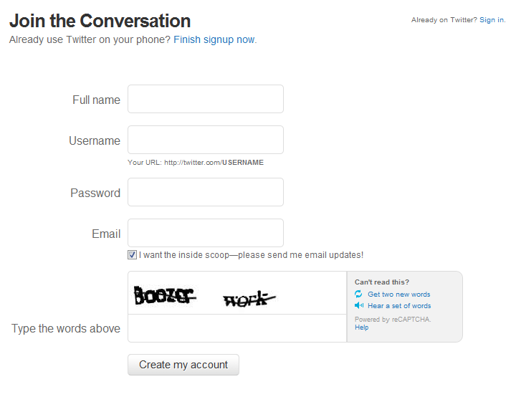
On the Twitter main page, simply click the green “Sign Up Now” button. You'll have to enter your first and last name and your preferred username. This could be your own name, your blog's name, your product's name, etc. Whatever “brand” you want to build, use that as your username.

First you'll be able to browse through the Twitter accounts of various celebrities, politicians, businesses, corporations, etc. Follow the ones you're interested in.

Next you can search your inbox for your contacts that are already on Twitter. Finally, the last step will be to search the names of others who you would like to follow.

Don't go overboard when it comes to following or you'll soon find that your Twitter page is far too “noisy” – you might miss the good Tweets among all the noise and clutter. Only follow people if you have a legitimate reason for doing so-- don't follow a bunch of strangers.

That's it! Yeah, it pretty much doesn't get any easier than that.

Creating Your Profile

If you wish to stand out on Twitter, it's recommended that you customize your profile. Upload a picture to use as your avatar – if your brand is you, upload a nice, friendly photograph of yourself. Otherwise you could make it your business logo, etc.

It is also possible to change the background of your Twitter profile. Go to the “Design” tab under “Settings” and you can either select one of Twitter's default backgrounds or upload one of your own. If you want to truly stand out, I recommend uploading one of your own. Just make sure the picture isn't too busy or your Twitter profile will look very unprofessional and give people a headache.

Twitter Language / Symbols

As with most modern inventions, there is a certain “language” you'll have to learn when it comes to using Twitter. When I first signed up, I was incredibly confused about what all of this stuff means. But I quickly got the hang of it and so will you!

- Retweet (RT): This means that the Tweet was originally posted by someone else and you are reposting it because you want to spread the word, you think it's funny, etc.
- Hash tag (#): Typing # followed by a keyword will categorize your Tweet so that others can easily find it by performing a search. Once you start using Twitter, you'll realize that MANY people use the hash tag in their Tweets – this can indicate a meme or trend that is quickly being spread through the Twit-o-sphere.
- @ symbol: Placing the @ symbol directly before a username shows that you are directly addressing that person (but the Tweet is still public). Clicking the arrow button when you hover over a user's tweet will let you do this automatically.
- Direct Message (DM): Typing d followed by a username will allow you to send them a Direct Message rather than having your Tweet appear publicly.
- Overheard (OH): OH at the beginning of the Tweet means that you overheard something funny/interesting that is not your own original idea.
- Nudge: Typing Nudge followed by a username will send the user a reminder to update and start tweeting again.
- FAV: Typing FAV followed by a username will favorite that user's last Tweet.
- GET: GET followed by a username will retrieve the user's last few updates.

How To Get Followers

Okay, so you've registered an account and set up your profile. You now understand the basics of Twitter symbols/language. And you're most likely following a few people.

Of course, Twitter is useless as a marketing tool if you don't have followers, so this should be your main objective.

First of all, go to Facebook, Myspace, and any other social networking sites you use. Post a link to your new Twitter account in your status update, urging people to follow you.

In your email, put the Twitter link in your signature, and do the same for forums (the Warrior Forum will put your link in a Twitter symbol under your username and avatar).

If you already have an email list, send out a blast talking about your new Twitter account and encouraging them to follow you. If you have a blog, write a post about it. If you use Wordpress, you'll also want to install a plugin that will easily allow your visitors to follow you. I'll cover that in more depth later on.

Basically, make your Twitter account visible wherever you have an internet presence.

Another way to gain followers is by simply following others. When you follow someone, they are notified by email. Very often, they'll be curious about you, check out your profile, and likely follow you back.

However, you have to be strategic. Don't expect results by following celebrities or extremely popular users, as they probably won't even notice you. Don't follow random strangers – why on earth would they be interested in you or what you're selling anyway?

One awesome function of Twitter is the ability to search what people are talking about. If you have a blog about gardening, you can search the keyword “gardening” and it will pull up everyone Tweeting about gardening.

You can even search for phrases such as, “need help gardening” or “plants keep dying”, etc. This way, you can find people in your niche who are suffering from a problem that you can (hopefully) resolve.

Keep in mind that you can only follow around 2000 people each day. It sounds like a lot, but if you use the Twitter search engine you might reach that limit sooner than you think.

There are various programs and online services that allow you to follow and unfollow people automatically, rather than going through the process manually (which can be an extremely tiring, boring process). I'll be covering those later.

Twitter Etiquette

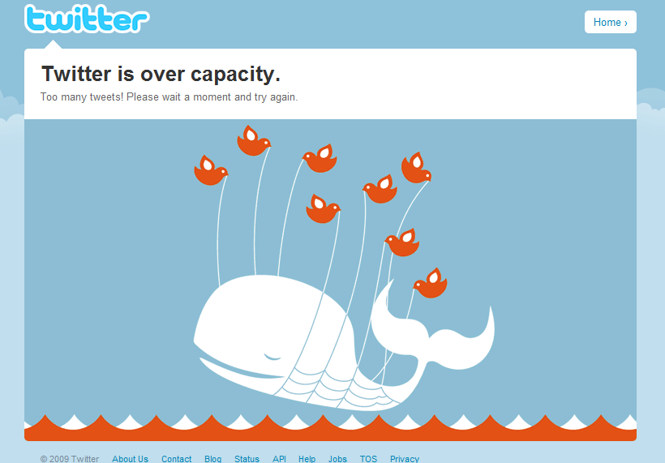
You should learn to treat Twitter seriously, just as you do all of your other business ventures. Learning proper Twitter etiquette is an important aspect of this.

- Don't tweet constantly! This should be obvious, but it's remarkable how many people tweet dozens, even hundreds of times in a single day. Be strategic with your tweets. There is no “magic number” – just use your intuition and you should be fine.

- Stay consistent. Tweet every day, or at least every other day. Tweeting once a week or once a month will not accomplish anything – it kind of defeats the purpose of being on Twitter altogether. People will forget who you are and why they decided to follow you in the first place.

- Only tweet about things that matter. The occasional “Wow these french fries are tasty” is fine – it shows your followers that you're human and that there's more to you than selling and marketing. But do NOT go overboard.

Usually the people who tweet dozens or hundreds of times a day are tweeting about trivial subjects that no one cares about. If you feel the need to tweet about your shoelaces or the zit on your cheek, register a second, personal Twitter account to share this kind of stuff with friends/family only – NOT your customers or business prospects.

- If you want to use Twitter like an instant messaging client, make sure that you are sending Direct Messages rather than publishing your tweets publicly. Chatting with someone over Twitter will clog up your followers' feeds and can be very, very annoying. Users may unfollow you as a result. So use common sense and download MSN or something if you want to chat in real time.

- No hard selling. Constantly tweeting “New blog post”, “New ebook buy it now!”, “Great software, check it out”, etc. etc. will not yield great results. Your followers will start viewing your tweets as SPAM. You will not gain a good reputation, you will not build trust, and you will not sell anything. Sorry. Twitter is meant for the SOFT sell – so you'll have to work on that.
Providing Value On Twitter

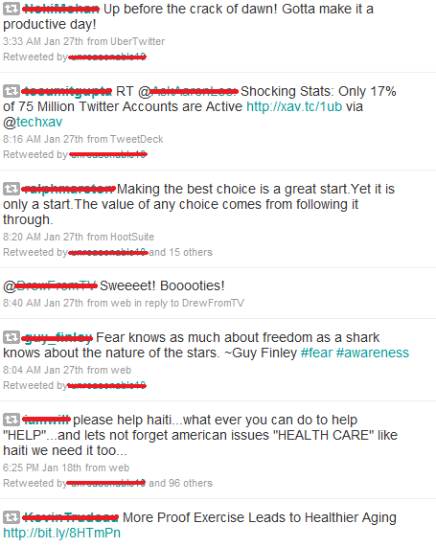

So now that I've told you what NOT to do when it comes to Twitter... you might be wondering, “what should I tweet about?”

Just as with your blog, website, and forum posts, your main goal should be to provide value. If you can manage to do that, you're golden!

Here are easy ways to provide value that don't take much effort at all:

- Retweet an interesting update from someone that you're following.

- Offer links to free and interesting stuff, like articles, pictures, and videos (not all your own stuff).

- Comment on current events / news.

- Post funny/profound/inspiring quotes.

- Tweet about interesting things that happened in your day or upcoming events that you're excited about. (actual things that your followers will be interested in, not the new episode of American Idol airing tonight.... unless your niche is American Idol of course!)

- Find something on Digg, Stumbleupon, etc. that really catches your attention. Write a blog post about it first, and then link to your blog post in your tweet. This way, instead of linking directly to the source, you're linking to your own blog. If it's something really neat it may go viral, causing a potential hurricane of traffic.

After you have been on Twitter for a while, look at your tweet history. Are you selling too hard? Not selling enough? Are you providing value with your tweets or just rambling on about random stuff every day? Would YOU follow yourself?

Analyze your tweets carefully and modify your strategy accordingly. Just as with a PPC campaign, monitor, track, and make changes as needed.

Writing Eye-Catching, Interesting Tweets

Twitter won't do you much good if no one bothers to click your links. Writing eye-catching, interesting tweets involves the same general concept as writing strong e-mail headlines. You must pique their interest and make them curious to see what you have to offer.

- Ask a provocative question. “Will's Obama's new tax reforms bring your small business to its knees?”

- Write a headline that sounds like news. “New Twitter software revolutionizes social networking!”

- Blunt, direct statements. “Free CPA Short Report – No Optin Required”

- Lists. “Ten Reasons Why You Need To Trash Your Iphone”

- How-to tweets. “How to get 1000 visitors to your blog – overnight!”

As you can see, it's not really rocket science. Just be creative. Instead of tweeting, “New SEO Ebook released today! Get it now!”, think of all the different ways you could say roughly the same thing in a more interesting fashion.

- “Revolutionary New SEO System Kicks Google's Ass!”

- “How much would you pay to kick Google's ass?”

- “What if I told you that everything you know about Google – IS WRONG?”

- “Tired of crap? Get the system that ACTUALLY WORKS.”

- “10 Reasons Why Your Website Isn't Ranking – And How To Fix It”

You get the idea.

If you're using bit.ly to shorten your URLs, you can actually track your links. This way, you can find out which headline is bringing in the most clicks, and replicate it again and again.

Of course, as I mentioned before, these “eye-catching” headline tweets should only be tossed in here and there. Keep the majority of your tweets free of advertising altogether, or people will quickly become fed up with your blatant, desperate marketing attempts.

Twitter Plugins

Most popular blogs are integrated in some way with the author's Twitter account. Establishing links between all of your online platforms is crucial to building your online presence. Your blog readers can become your followers, and vice versa.

There are several different plugins / widgets to choose from.

- Tweetmeme Button: Allows your blog posts to be retweeted with the click of a button.

- TweetThis Button: Allows users to share your blog posts on Twitter.

- The Twitter Updater: Automatically publishes updates to your Twitter account when new posts or changes are made to your blog.

- Twitter Tools: Integrates your blog and Twitter account, allowing you to easily put tweets on your blog and blog links in your tweets, all from the Wordpress control panel.

- Twitt-twoo: Tweet directly from the sidebar of your blog (pretty cool!)

- Twitter Feed: Automatically post your blog updates on your Twitter account.

- Wicket Twitter Widget: Display your tweets on the sidebar of your blog.

- TweetSuite: Integrates Twitter and Wordpress, automatically tweets about new posts, gives you Retweet and Tweet This buttons, etc.

- TwitterCounter: Places a counter on your blog stating (bragging about) the number of followers you have.

- NewsTweet: Input keywords or keyword phrases and this plugin will pull “news feeds” in your niche from Twitter to add to your sidebar.

Twitter Tools

- TweetDeck: Twitter desktop client that allows you to tweet remotely, keep track your followers, direct messages, replies, etc. It supports multiple Twitter accounts and is an awesome tool to have. You can keep track of Twitter without having to constantly visit the Twitter website.

- Twitpic: Share your pictures and photographs on Twitter.

- Twitbin: Firefox plugin that allows you to monitor your Twitter conversations from a sidebar in your browser. A great way to multi-task and keep an eye on your Twitter account while you're busy doing other things.

- GroupTweet: Lets you send a tweet to only a select group of people.

Twitter Services

- Twilert: Sign up for email alerts whenever someone tweets about a particular keyword or mentions your name/product.

- Qwitter: Sign up for email alerts when someone stops following you.

- TweetLater/Social Oomph: Automates the tweeting process. Input as many tweets as you want and schedule them to be released at certain times.

- TweetTake: Backup your Twitter account and followers. Twitter is not immune to black-outs and hackers. In July 2008, hundreds of Twitter users lost scores of followers literally overnight. It's better to be safe than sorry.

More Ways To Make Money With Twitter

Besides using your own Twitter account to promote your blog, products, services, etc., are there any other ways you can drive traffic and make money using Twitter?

The answer is a resounding YES!

Many people don't realize that paid advertising is available on Twitter. You can sign up to be either a publisher or an advertiser. Generally, publishers are paid to publish sponsored tweets, and the more followers they have, the higher the payout. Advertisers can use PPC (Revtwt and Twivert) or simply pay for a set number of sponsored tweets.

There are several advertising networks on Twitter, the most popular being:

- Revtwt
- Twivert
- BeTweeted
- Be A Magpie
- Sponsored Tweets
- TweetROI
- Adcause
- Tweetbucks
- Adjix
- Twittad

If you have a bit of money to spend, you might find great results advertising on Twitter. Or if you have an account with a fair bit of followers, signing up as a publisher might be a way to make some extra cash.

If you wish to advertise using PPC, the rules are more or less the same as Google Adwords or any other PPC program. You must use your own discretion. Certain strategies must be employed – you must constantly be tracking and modifying your campaigns to ensure positive ROI.

I'm not going to teach you how to make money using PPC advertising, as this is not what this ebook is about. But the option is available if that is a route that you think you would like to take.

Twitter Tips and Secrets

Here is a random compilation of Twitter tips & secrets that you can use to maximize your earning potential with Twitter in your marketing efforts!

- If you have tons of followers, chances are good that not all of them will read every tweet that you send. If you got a good reaction or a good bit of traffic from one of your tweets, try posting it again at another time. Preface it with something like, “Did you miss this?” or “Last week retweet”.

- On the right sidebar of your Twitter page, you'll see a link to your RSS feed. Take this feed and submit it to RSS directories, just as you would do with a blog! This will increase exposure to your tweets.

- If you have lots of friends on Facebook, there is an application you can use to integrate your Twitter feed into your Facebook feed. This can lead to more followers and larger exposure overall. An application called Twittersync will actually post each tweet as a status update on your Facebook page. Unfortunately, it turns your links into text, so that kind of sucks.

- Interact with your followers and take an active interest in them by replying to their tweets and retweeting. Schmooze with them – offer compliments, joke around, etc. Remember that Twitter is a community.

- If your goal is marketing, be direct with your Bio. Tell them exactly who you are. “I'm a 27-year-old marketer and blogger living in LA!” Don't post random song lyrics or an inside joke. Leave that to your personal Myspace page.

- Remember that everything you do on Twitter represents your brand. Tweeting “OMG I got so drunk last night I barfed up nachos on my friend's shoes” probably isn't the best image to portray, unless your demographic happens to be male college students or something like that.

- Don't get addicted to Twitter. Checking it every five minutes will start to interfere with the rest of your life and your business. Keep a schedule and force yourself to check it no more than every two hours or so. If you intend to publish a tweet, it's easy to start reading up on everyone else's tweets, and before you know it, half an hour has passed and you can't remember what you were going to tweet about in the first place.

Conclusion

So we have reached the end. What have we learned today?

- Twitter is fun
- Twitter is easy
- Twitter can drive insane amounts of traffic to your site/blog
- Twitter can help to build your brand
- Twitter can help to find new business contacts and JV partners
- Twitter can connect you to millions of people around the world in real-time
- Twitter is THE FUTURE!

Quite a rap sheet, isn't it? I hope you have gained enough knowledge and power from this ebook to go out and take advantage of the Twitter Boom! If you don't, your business will surely be left sitting in the dust.

